**KR3_KPI5:(2) Fatty Acid headload & H2 Loop reactor Hydrogen valve logic modification carried out**

**From:** Sachin Lohar   
**Sent:** Thursday, September 08, 2016 12:18 PM  
**To:** Ajay Kumbhar  
**Cc:** Prashant Pathak; Dinesh Danav; Fatty Acid  
**Subject:** RE: Please provide the logic in loop reactor as follows,

Dear Ajay,

This is reference to below mail,logic implemented in DCS system & same trial taken found okay.

1 )If reaction temperature of reactors (V-701 A) increases above 215 Deg C then the hydrogen line control valve (PCV-301) will be close automatically.

    PCV-301 closes on TI-310 & TI-307 –HHAIND of 215 Deg C.

2)If reaction temperature of reactors (V-701 B) increases above 215 Deg C then the hydrogen line control valve (PCV-701BH) will be close automatically.

    PCV-701BH closes on TI-310B & TI-307B –HHAIND of 215 Deg C

Kindly submit us the duly signed copy of Logic modification format against the same.

Thanks & Regards,

**Sachin Lohar| Sr. Manager| Instrumentation Dept.**

VVF [India] Limited |Plot V41, MIDC Industrial Area, Taloja, District Raigad 410 208, Maharashtra, India | T: +91 22 39213926|M: +9819427120| W: [www.vvfltd.com](http://www.vvfltd.com/)

**KR3_KPI5: (3)Fatty Acid Pump around condenser new valve(FCV-E357) installation & DCS modification carried out in August'2016**

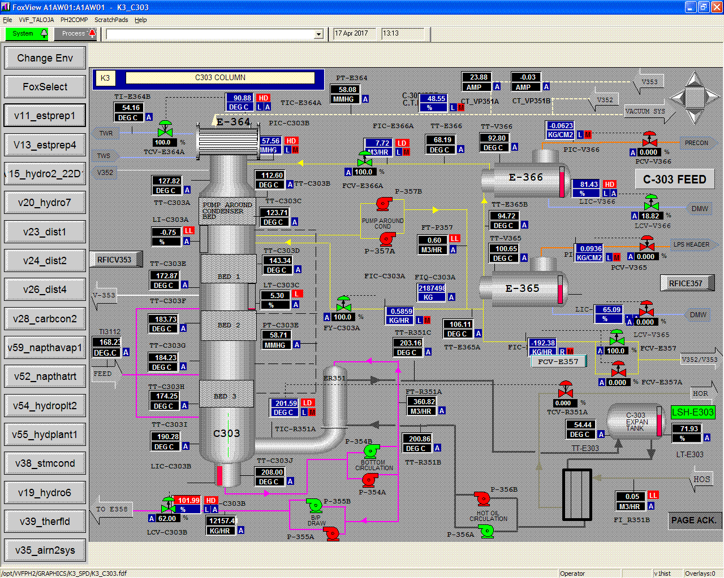

**KR3_KPI5:(4) Fatty Acid Tankfarm condensate tank(T820) level switch provided & logic implementation carried out for Pump start/stop**

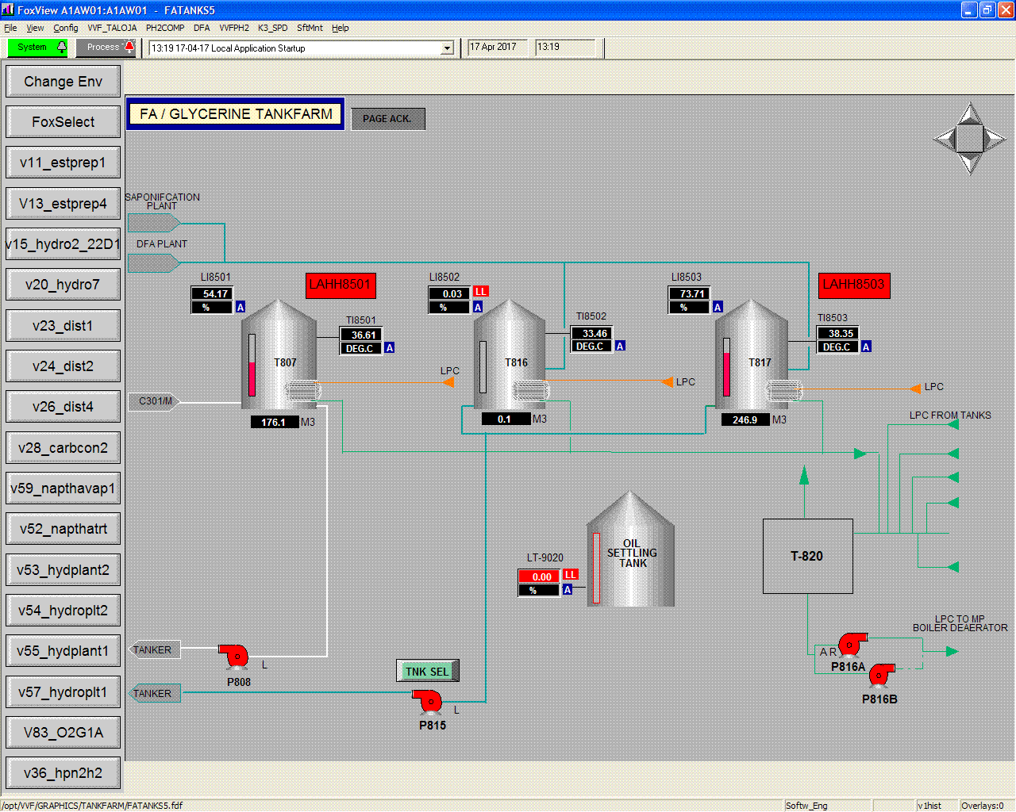

**KR3_KPI5:(1) & (3)Fatty Acid Pre-heater thermowll & RTD sensor location to be relocated point added in supply/return line**

**From:** Sachin Lohar   
**Sent:** Saturday, October 08, 2016 2:28 PM  
**To:** Lakhansingh Meena; Amey Deshpande  
**Cc:** Prabhat Das; Aniruddha Bansod; Prasad Kale; Dinesh Danav; Prashant Pathak; Vilas Kakade  
**Subject:** RE: Modification in Thermicf Fluid line in plant_PREHEATER CIRCUIT THERMOWELL INSTALLATION.

Dear Amey/ Lakhan,

This is reference to below mail for new thermowell installation in Fatty Acid Plant preheater circuit.

All mentioned thermowell’s received in store so request you to carry out thermowell installation & fabrication work for the same.

After this fabrication activity we wll be provide the DCS indication facility for this temperature tags.

Thanks & Regards,

**Sachin Lohar| Sr. Manager| Instrumentation Dept.**

VVF [India] Limited |Plot V41, MIDC Industrial Area, Taloja, District Raigad 410 208, Maharashtra, India | T: +91 22 39213926|M: +9819427120| W: [www.vvfltd.com](http://www.vvfltd.com/)

[cid:image001.png@01CFFF28.DE9F72C0](https://www.facebook.com/VVFGroup)  cid:image002.jpg@01CFFF28.DE9F72C0  cid:image003.jpg@01CFFF28.DE9F72C0

DISCLAIMER: This email was sent from the VVF Group of companies. This email may contain information that is confidential, legally privileged or otherwise protected from disclosure. If you are not the intended recipient of this email, you are not entitled to use, disclose, distribute, copy, print, disseminate or rely on this email in any way. We have taken steps to ensure that this email is free from computer viruses and the like. It is, however, the recipient's responsibility to ensure that it is actually virus free.

**From:** Lakhansingh Meena   
**Sent:** Tuesday, June 14, 2016 12:26 PM  
**To:** Sachin Lohar; Amey Deshpande  
**Cc:** Prabhat Das; Aniruddha Bansod; Prasad Kale; Dinesh Danav; Prashant Pathak  
**Subject:** RE: Modification in Thermicf Fluid line in plant

Dear Sir

Please find attached

|  |  |  |  |  |  |  |  |
| --- | --- | --- | --- | --- | --- | --- | --- |
| Sr No | Thermic fluid Consumer | FT Tag No | NPS (Inches) | Location | Floor | Inlet TT | Outlet TT |
| 1 | C-301 Preheater | FT3206 | 2 | Behind C-301 | 4 | TT3216 | TT3214 |
| 2 | C-303 Preheater | FT359C | 8 | Near E-359 | 4 | TT359A | TT359B |
| 4 | C-401 Preheater | FT4201 | 2 | in front of C-401 preheater | 2 | TT4351 | TT4203 |
| 5 | C-402 Calendriya | FI4302 | 1 | Below c-402 calendriya | 2 | TI4308 | TI4309 |
| 6 | C-501 Preheater | 22FT05 | 3 | In front of C-501 | 4 | 22TT123 | 22TT124 |
| 7 | Old SPD | FT50519 | 3 | Behind Old SPD | 5 | TT50509C | TT50509E |
| 8 | New SPD Preheater | FT E455C | 6 | In front of C-303 reboiler | 4 | TT E455A | TT E455B |
| 9 | New SPD Jacket | FT E451C | TI SPD451B | TI SPD451A |

Regards

**Lakhan Singh Meena**

VVF [India] Limited |Plot No. V - 41, MIDC Industrial Area, Taloja, District Raigad 410 208, Maharashtra, India | T: +91 22 3921 3953|M: +91 9076236778|W: [www.vvfltd.com](http://www.vvfltd.com/)

[cid:image001.png@01CFFF28.DE9F72C0](https://www.facebook.com/VVFGroup)  [cid:image002.jpg@01CFFF28.DE9F72C0](https://www.linkedin.com/company/vvf-ltd.?trk=top_nav_home)  [cid:image003.jpg@01CFFF28.DE9F72C0](https://www.youtube.com/user/VVFGroup)

DISCLAIMER: This email was sent from the VVF Group of companies. This email may contain information that is confidential, legally privileged or otherwise protected from disclosure. If you are not the intended recipient of this email, you are not entitled to use, disclose, distribute, copy, print, disseminate or rely on this email in any way. We have taken steps to ensure that this email is free from computer viruses and the like. It is, however, the recipient's responsibility to ensure that it is actually virus free.



**From:** Sachin Lohar   
**Sent:** Tuesday, June 14, 2016 12:18 PM  
**To:** Amey Deshpande  
**Cc:** Prabhat Das; Aniruddha Bansod; Prasad Kale; Lakhansingh Meena; Dinesh Danav; Prashant Pathak  
**Subject:** RE: Modification in Thermicf Fluid line in plant

Dear Amey,

Kindly send the process datasheet for below mentioned TT  along with DCS Tag number.

Thanks & Regards,

**Sachin Lohar| Sr. Manager| Instrumentation Dept.**

VVF [India] Limited |Plot V41, MIDC Industrial Area, Taloja, District Raigad 410 208, Maharashtra, India | T: +91 22 39213926|M: +9819427120| W: [www.vvfltd.com](http://www.vvfltd.com/)

[cid:image001.png@01CFFF28.DE9F72C0](https://www.facebook.com/VVFGroup)  cid:image002.jpg@01CFFF28.DE9F72C0  cid:image003.jpg@01CFFF28.DE9F72C0

DISCLAIMER: This email was sent from the VVF Group of companies. This email may contain information that is confidential, legally privileged or otherwise protected from disclosure. If you are not the intended recipient of this email, you are not entitled to use, disclose, distribute, copy, print, disseminate or rely on this email in any way. We have taken steps to ensure that this email is free from computer viruses and the like. It is, however, the recipient's responsibility to ensure that it is actually virus free.

**From:** Amey Deshpande   
**Sent:** Tuesday, May 24, 2016 11:02 AM  
**To:** Prashant Pathak; Dinesh Danav; Sachin Lohar  
**Cc:** Prabhat Das; Aniruddha Bansod; Prasad Kale; Lakhansingh Meena  
**Subject:** FW: Modification in Thermicf Fluid line in plant

Dear Sir,

Based on discussion and Plant visit with Mr. Sachin Lohar & Mr. Dinesh Danav ,we had finalized TT requirement and locations in thermic fluid lines .

Please go through list of TT requirement mentioned below along with line size:

|  |  |  |  |  |  |
| --- | --- | --- | --- | --- | --- |
| **Sr No** | **Thermic fluid Consumer** | **FT Tag No** | **NPS (Inches)** | **Location** | **Floor** |
| 1 | C-301 Preheater | FT3206 | **2** | Behind C-301 | 4 |
| 2 | C-303 Preheater | FT359C | **8** | Near E-359 | 4 |
| 4 | C-401 Preheater | FT4201 | **2** | in front of C-401 preheater | 2 |
| 5 | C-402 Calendriya | FI4302 | **1** | Below c-402 calendriya | 2 |
| 6 | C-501 Preheater | 22FT05 | **3** | In front of C-501 | 4 |
| 7 | Old SPD | FT50519 | **3** | Behind Old SPD | 5 |
| 8 | New SPD Preheater | FT E455C | **6** | In front of C-303 reboiler | 4 |
| 9 | New SPD Jacket | FT E451C |

Please do the needful to complete the job.

**Regards**

**Amey Deshpande| Assistant Manager | Technical Services**

VVF [India] Limited |Plot V41, MIDC Industrial Area, Taloja, District Raigad 410 208, Maharashtra, India | T: +91 22 3921 3900| M: 7744880089 |W: [www.vvfltd.com](http://www.vvfltd.com/)